1.1)The first sheet should have a total discount, profit, quantity and sales (KPI form at preferred means only number – no chart )

Ans:-

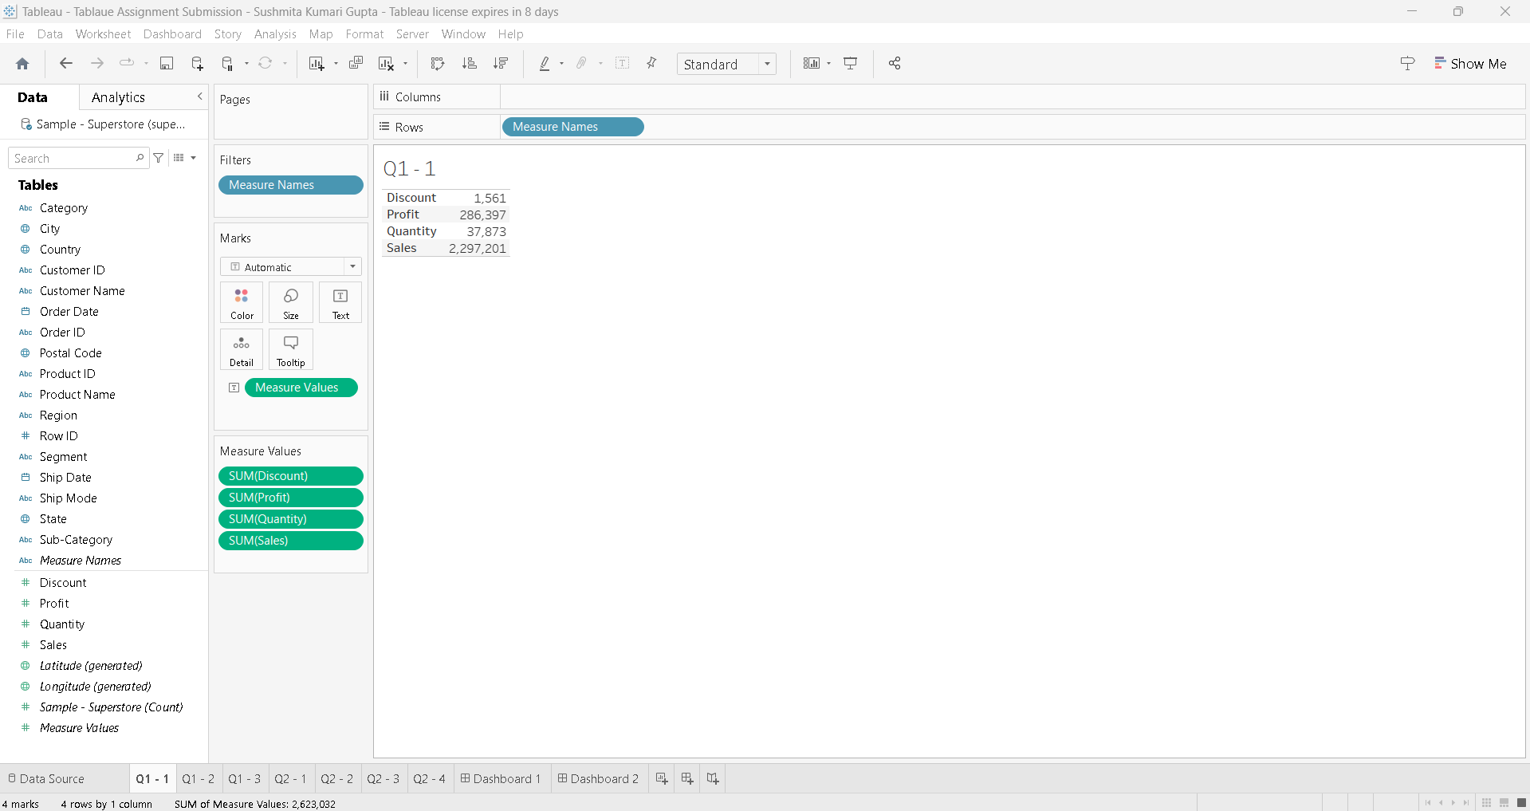

1.2)The second sheet shows monthly sales per year.

Ans:-

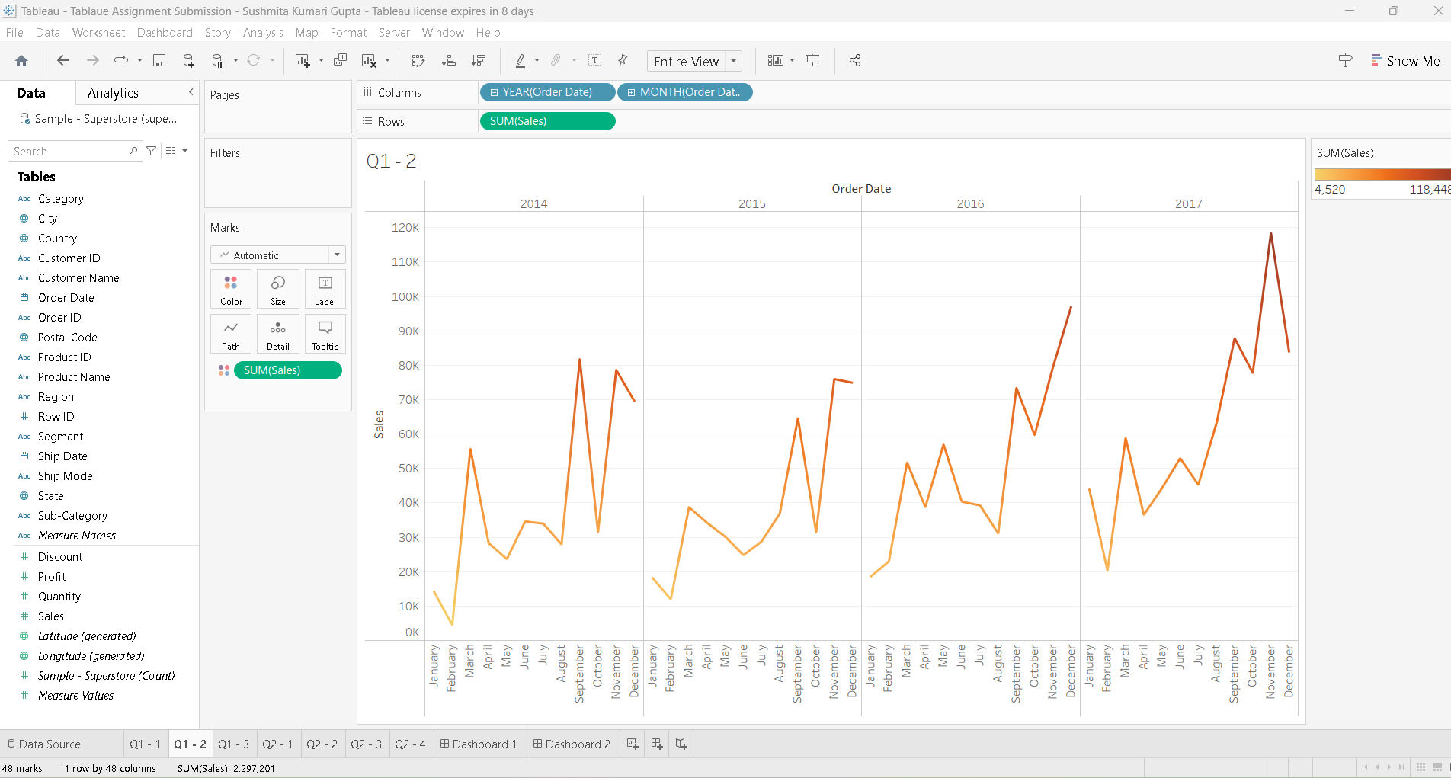

1.3)The third sheet shows the monthly profit per year.

Ans:-

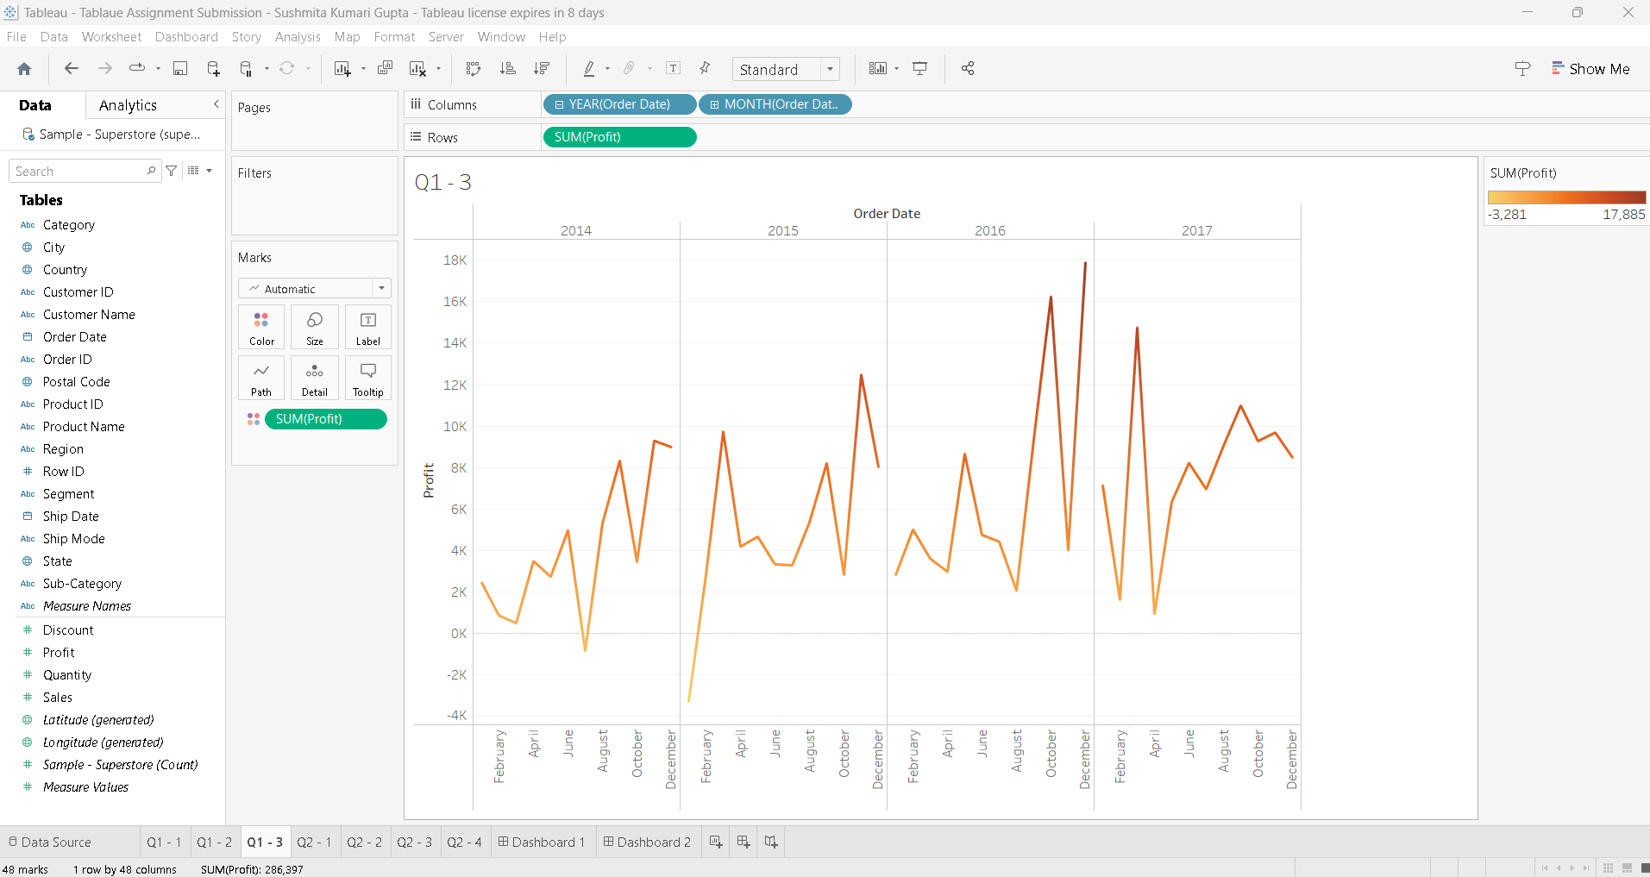

2.1)Top 5 cities that bear a maximum loss.

Ans:-

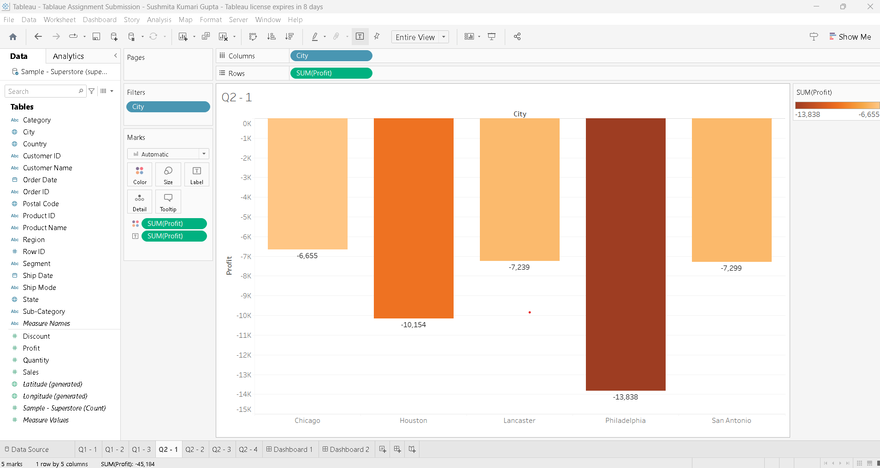

2.2)Which is the region with the highest sales ?

Ans:-

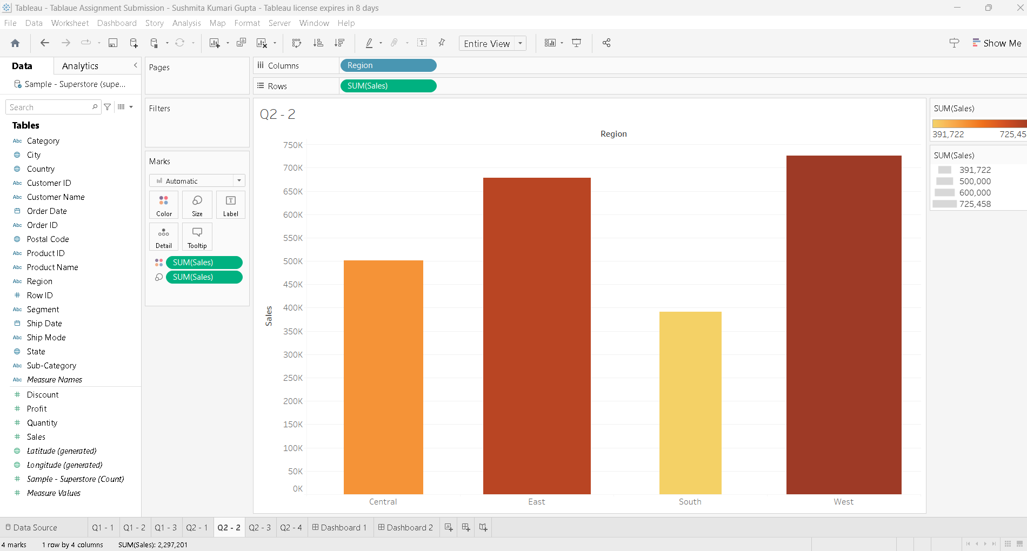

2.3)Name the category in the region with the highest sales .

Ans:-

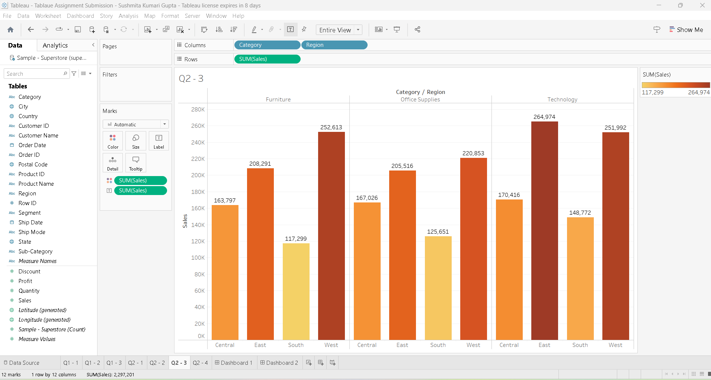

2.4)Which state has the highest quantity of orders ?

Ans:-

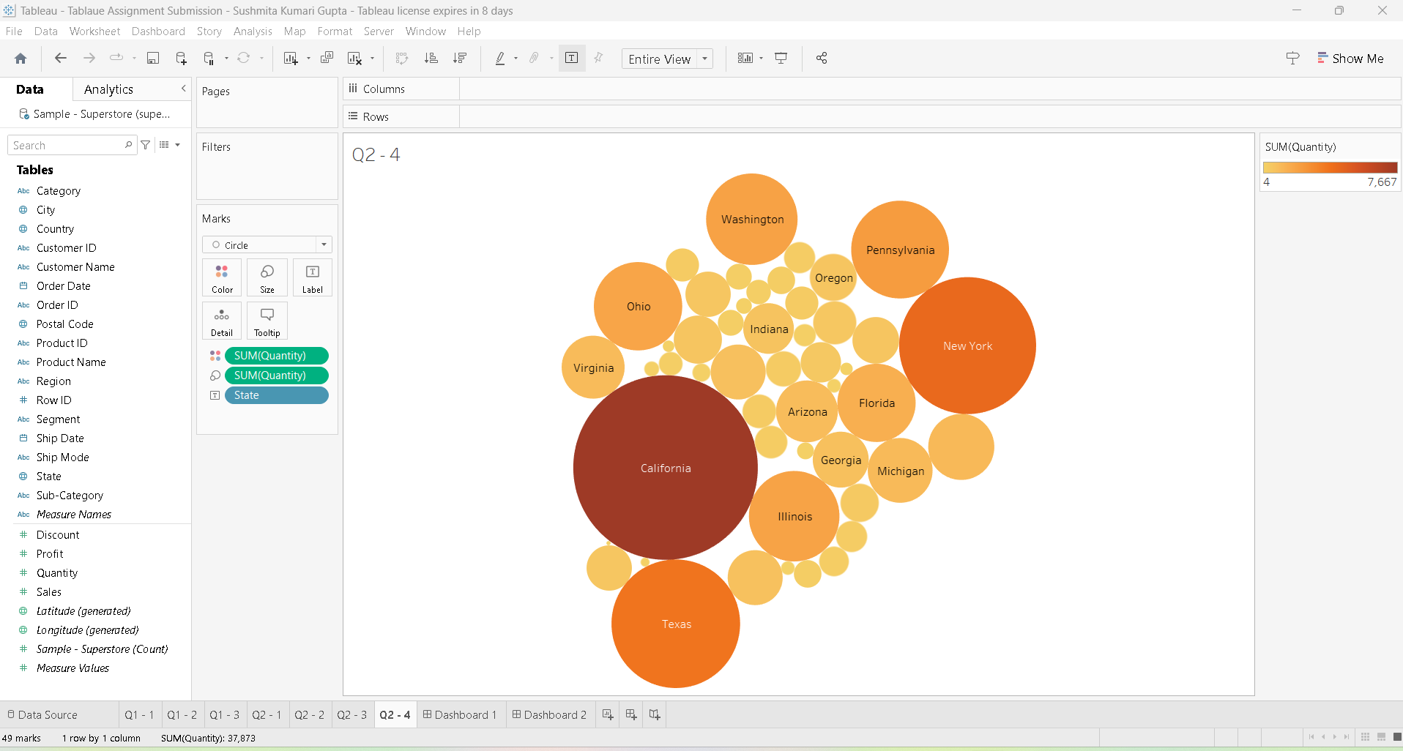

Dashboard :-

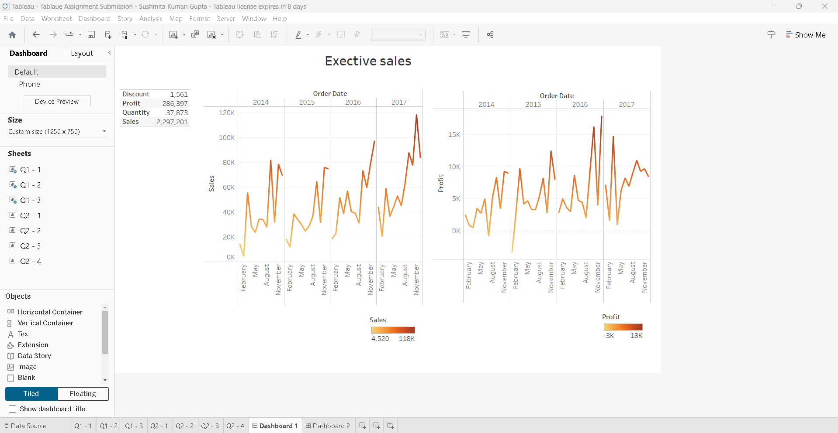

Dashboard :-

